**CSE499A.10 - Supervise.ly Review**

**Supervise.ly** is a powerful platform for computer vision development, where individual researchers and large teams can annotate and experiment with **datasets** and **neural** **networks**. It helps people with and without machine learning expertise to create state-of-the-art computer vision applications.

**Supervise.ly** was first developed at **deepsystems.ai** as a solution to deal with everyday task of large datasets annotation. The name Supervise.ly comes from machine learning term supervised learning — when we use a known dataset (called the training dataset) to make predictions. Supervise.ly is all about datasets and using them to build models.

Working Process according to **Supervise.ly** website:

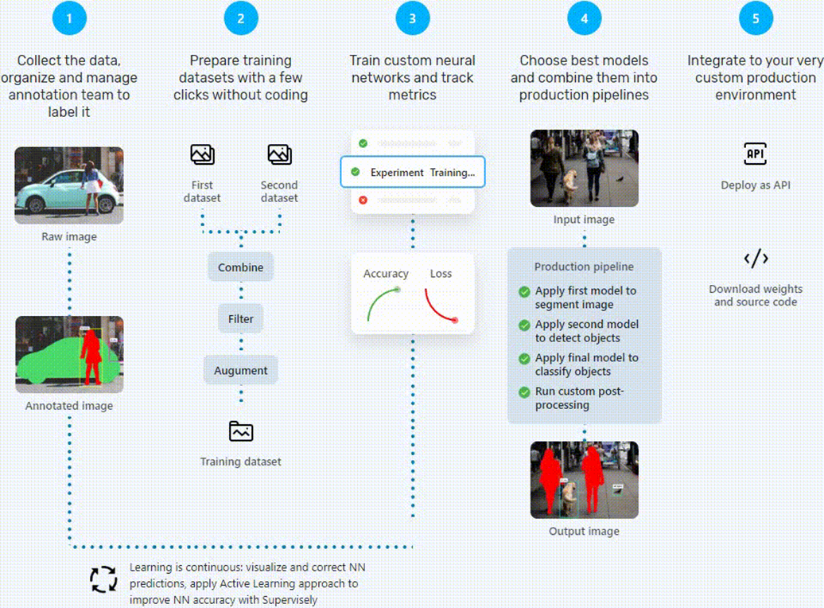

**Workflow:**

As the project is related to **Image Annotation**, the task was to review **Supervise.ly** & test its service.

Initially 60 roads images were gathered to **train** and **apply** Neural Networks using **Supervise.ly**.

The images were annotated as **Paved**, **Puddle** & **Hole** using **Supervise.ly** **Smart** **Tool**.

After labeling, DTL (Data Transformation Language) was run for training & validation tagging. 50 images were tagged for training and 10 for validation.

Then the pretrained neural network Faster R-CNN Inception v2 (COCO) was trained on the dataset.

Finally, the trained model was tested on few images & resulted about 33% accuracy. The model was mainly able to annotate **Paved** roads.

**Steps:**

1. Import the data – 60 Road Images
2. Label the data (Annotation) with **Supervise.ly Smart Tool**

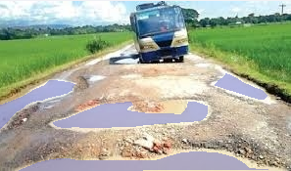 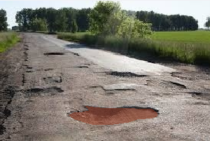

**Puddle** **Hole**

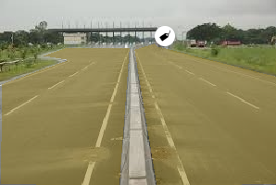

**Paved**

1. Data preparation – Using DTL (Data Transformation Language) for Training & Validation data.

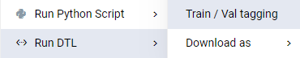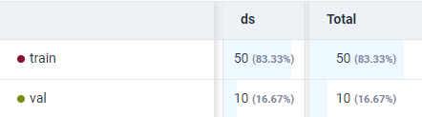

1. Adding own machine to the computational Cluster - In which users can connect their own computers or servers and use them to distribute tasks.

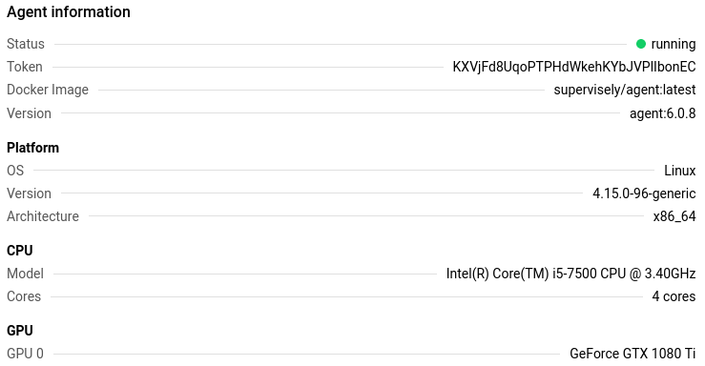

1. Add a pretrained model - Faster R-CNN Inception v2 (COCO)

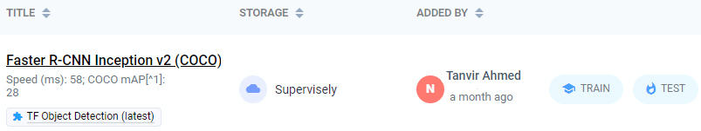

1. Start training the pretrained model on the dataset.



1. Test the trained model with testing dataset



1. Result

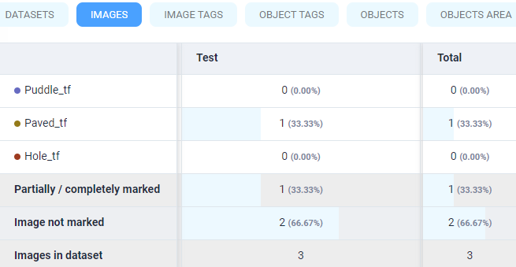

**Challenges:**

In Step 2: Annotating a large training dataset is a tiresome process.

In Step 4: It was made sure that the computer used in **Supervise.ly** meets these requirements:

1. Linux OS (Kernel 3.10)
2. Docker (Version 18.0)
3. GPU (CUDA 9.0) - for training and inference tasks
4. Nvidia-docker - for training and inference tasks

For that extensive research was done & installation instructions were followed thoroughly. Also, a lot of codes were executed in the terminal accurately for setting up the computational machine on Linux OS. A person who want to use **Supervise.ly** has to familiarize with the process of adding a machine.

So, adding a new machine to the cluster is a long process and it does not support Windows OS. Linux OS is a must. The process is not very newbie friendly.

**Conclusion:**

After annotating & adding a machine, a pretrained model was trained on the dataset. When the trained model was tested on the test dataset, it annotated few classes.

Any person can use **Supervise.ly** with any level of coding experience. But the process of adding a new machine can be challenging for newbies. Also, custom neural networks can be imported and applied to the dataset.

**Supervise.ly** is mainly for researchers with a large team. Tasks like annotation can be divided among individuals in a team. With a large annotated image dataset, it can give higher accuracy. But the annotation process on large dataset can be lengthy and exhausting. Active learning should be applied here to reduce the effort.

**References:**

1. **Supervise.ly** Web Platform - <https://supervise.ly>
2. Add / Restart / Delete agent – **Supervise.ly** - <https://docs.supervise.ly/customization/agents/add_delete_node>
3. 4 Steps to Setting up a **Supervise.ly** Deep Learning Cluster - <https://www.youtube.com/watch?v=el07zd4Dzsg>
4. Deep Systems – **Supervise.ly** Playlist - <https://www.youtube.com/playlist?list=PLDo7qx2mEhsr3ugO-MbJRB9DI-7JKgFen>